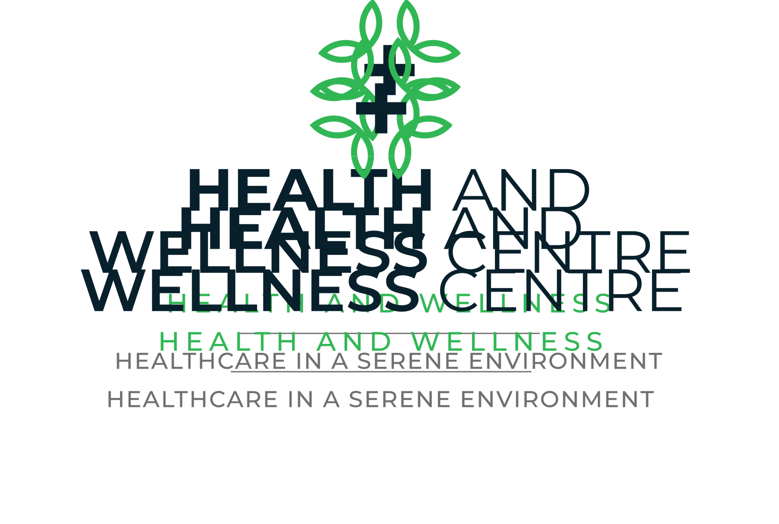

|  |  |
| --- | --- |
| 28 clinics |  |
| Areas starting from 47 m2 | Sandy’s Creations Resort |
| Ability for extensions |
| Kafue Road, Chilanga, Lusaka, Zambia |
|  |

Our Vision

Located 11 kilometres from the centre of Lusaka, our health and wellness centre is surrounded by botanical gardens keeping us from the hustle and bustle of town. Our surroundings will put you at ease straightaway.

The Health and Wellness Centre is dedicated to offering a range of medical services embodying both physical and mental health through a multi-disciplinary team.

We are putting together a range of services that compliment each other. We have an on -site gym and swimming pool to compliment our medical services, along with short and long stay apartments to facilitate comfortable rehabilitation should a patient need it.

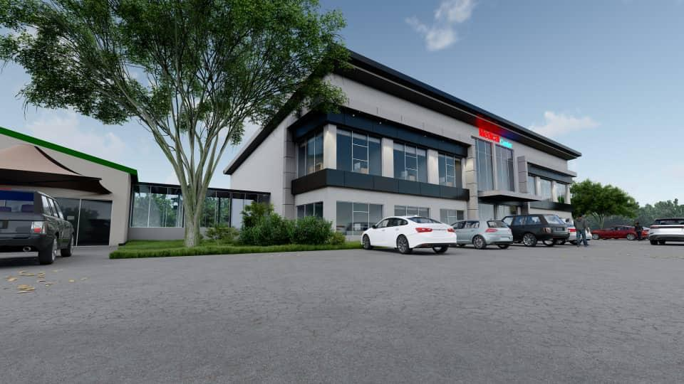

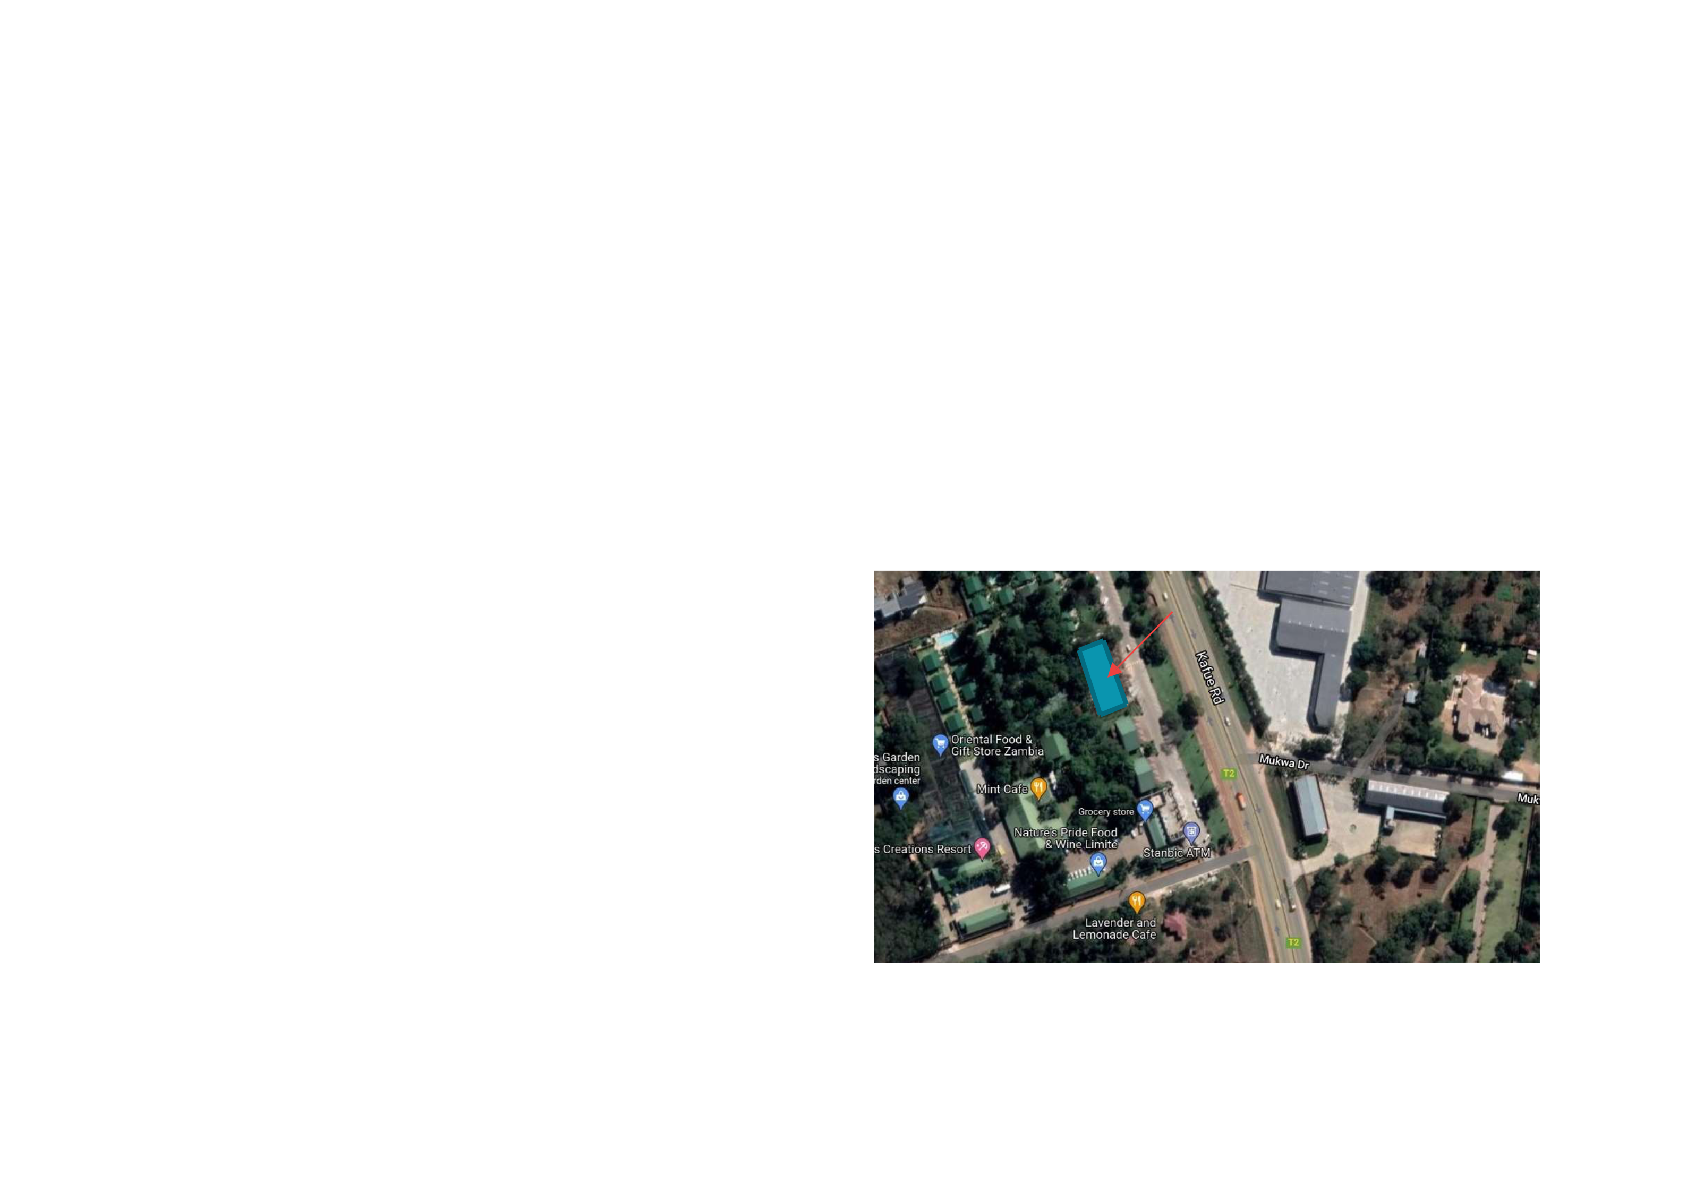

General Data & Building Location

2

**General Data**

The Building Consists of 28 Clinics with the option to join clinics for larger spaces.

Each floor has 2 public toilets at the far ends to serve all building users.

An open staircase and a glass elevator are centralized in the building to serve all clinics without blocking the entrance view.

**Location**

The building is located at Sandy’s Creations resort on Kafue Road, Chilanga, Lusaka, Zambia.

Medical Center

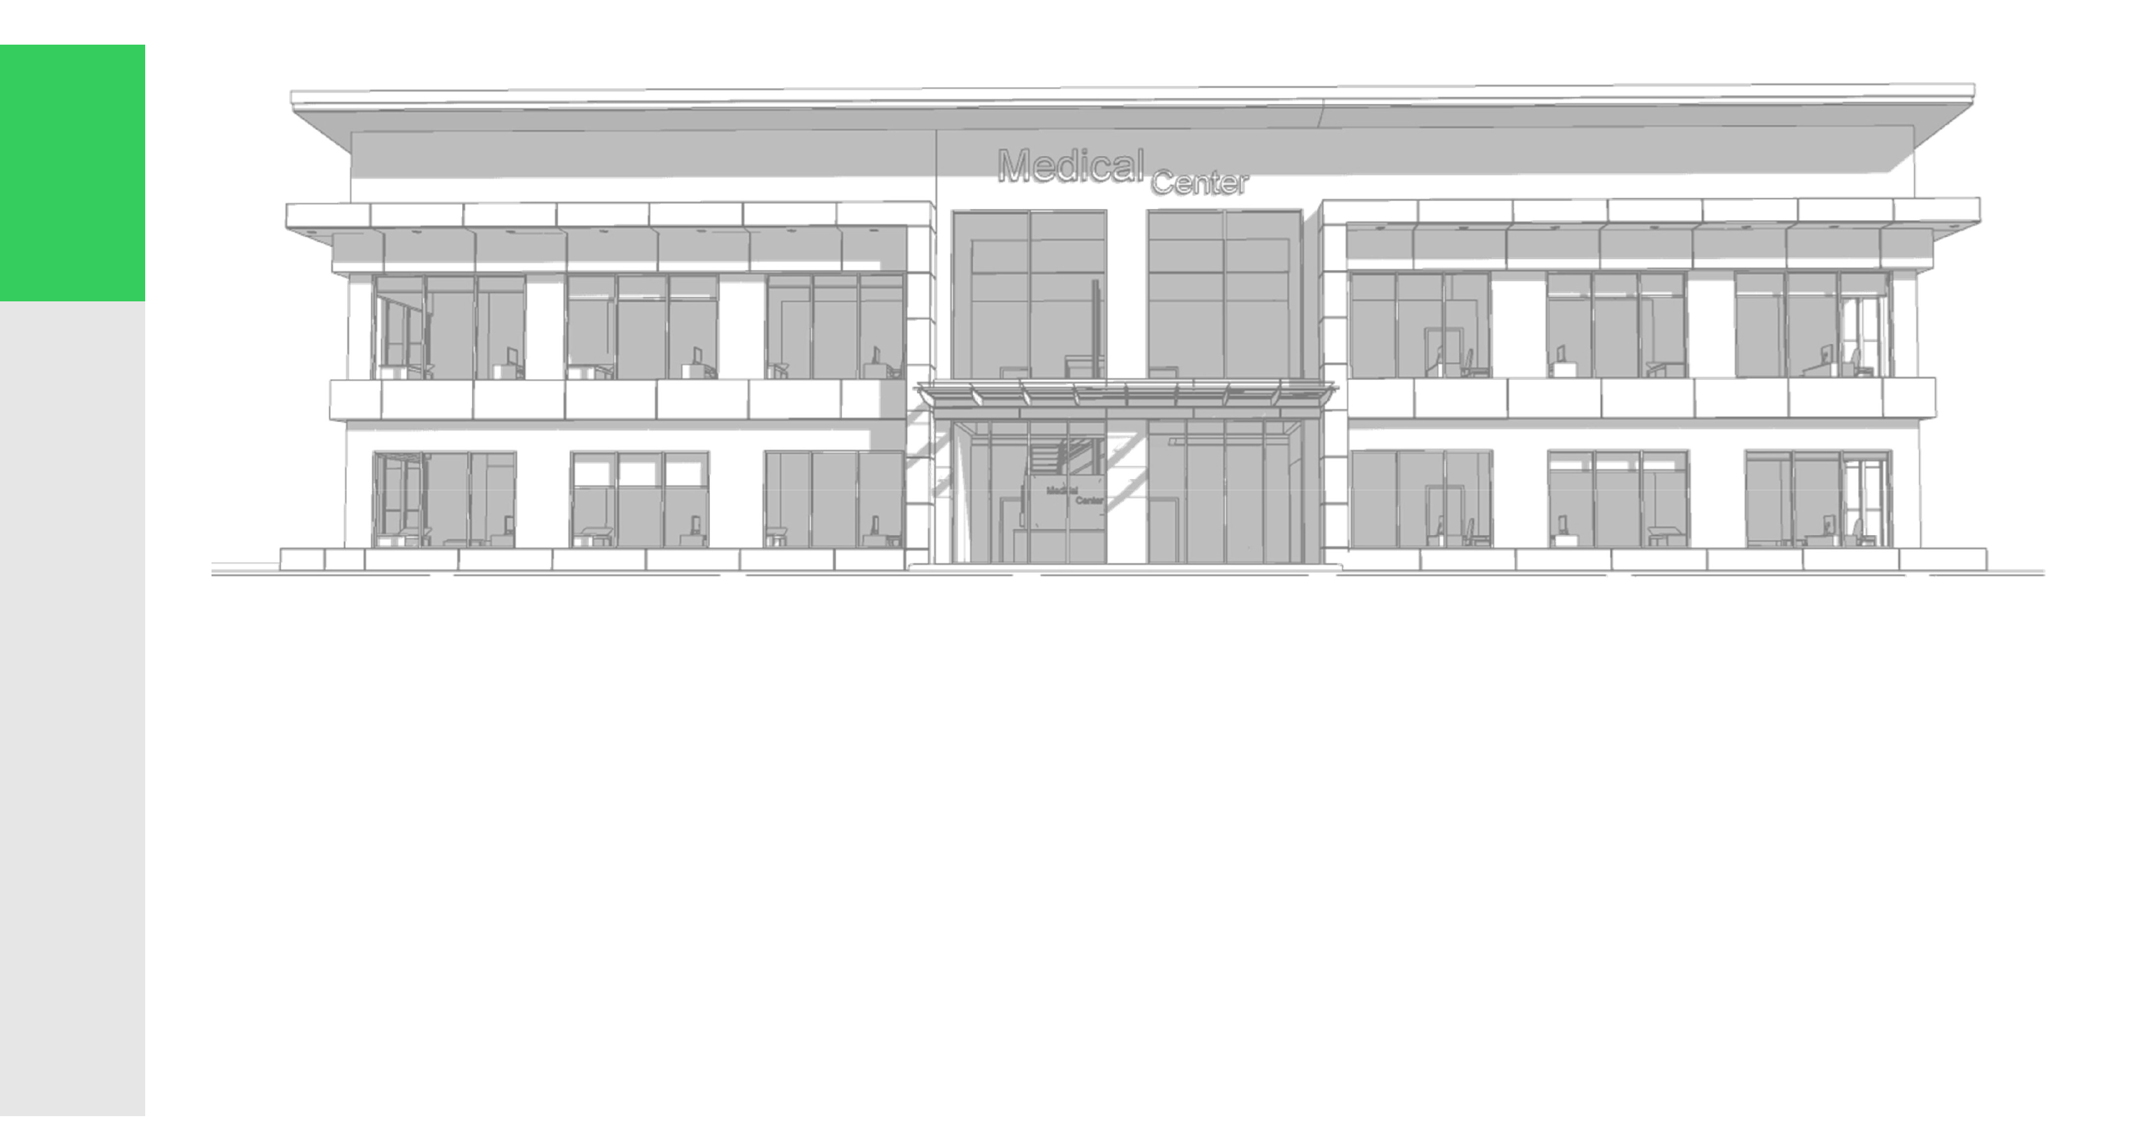

3

**FLOORLAYOUTS**

**GroundFloorLayout GroundFloorSectionbox FirstFloorlayout**

**FirstFloorSectionBox**



Ground Floor Layout & Section Box

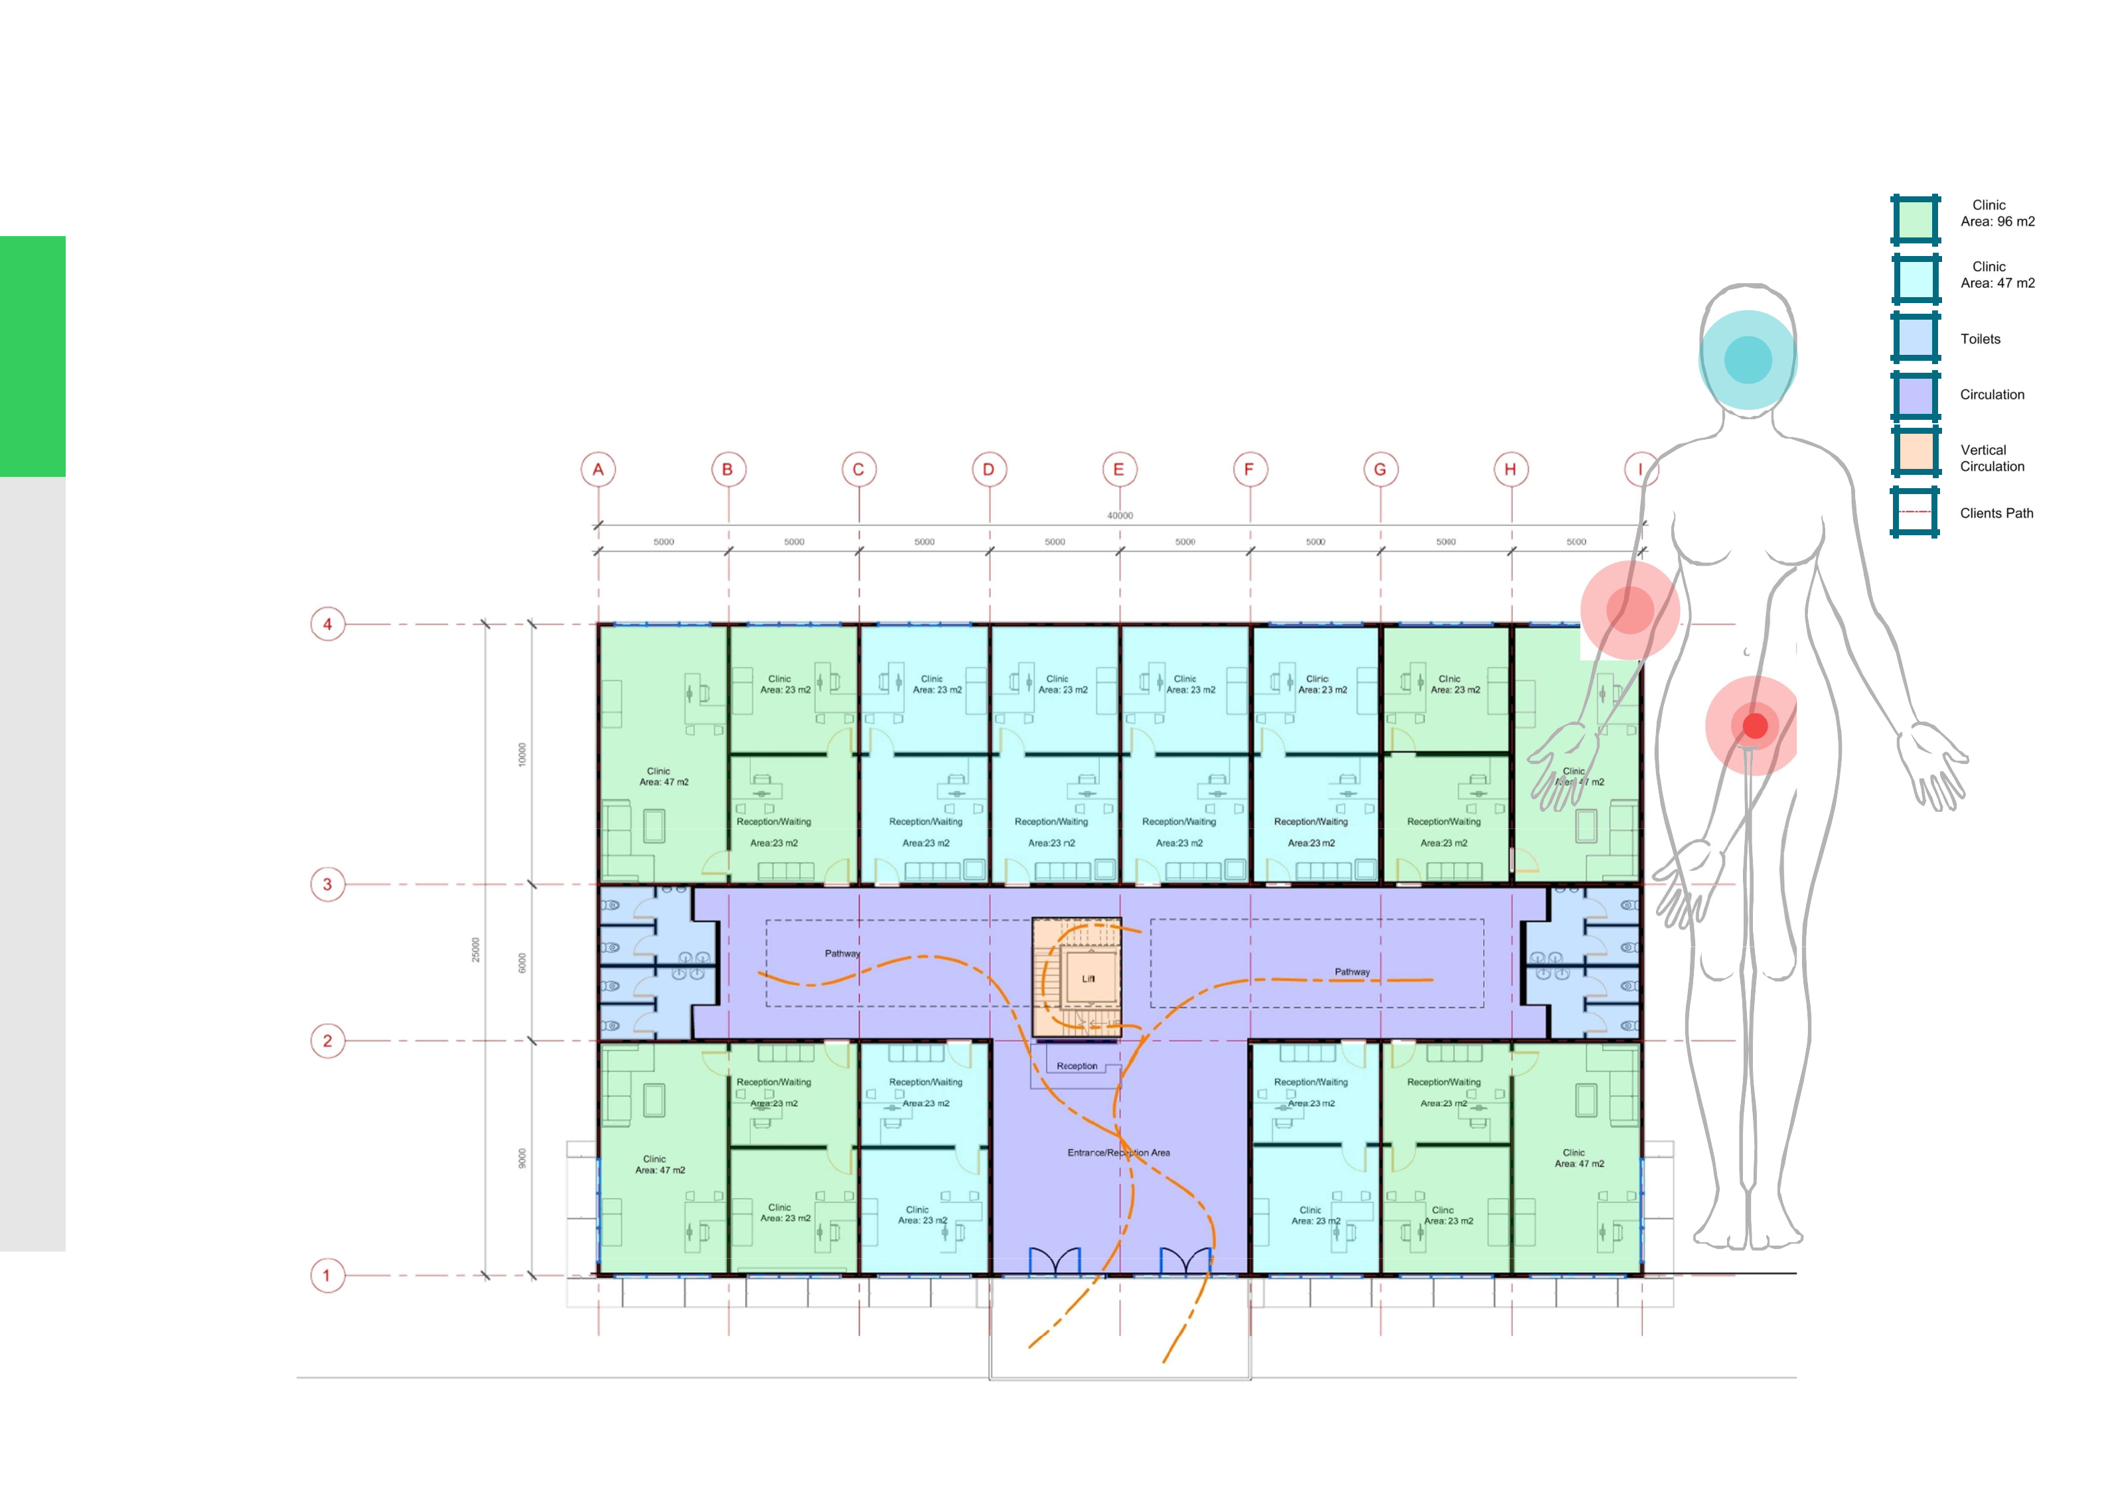

5

**Layout**

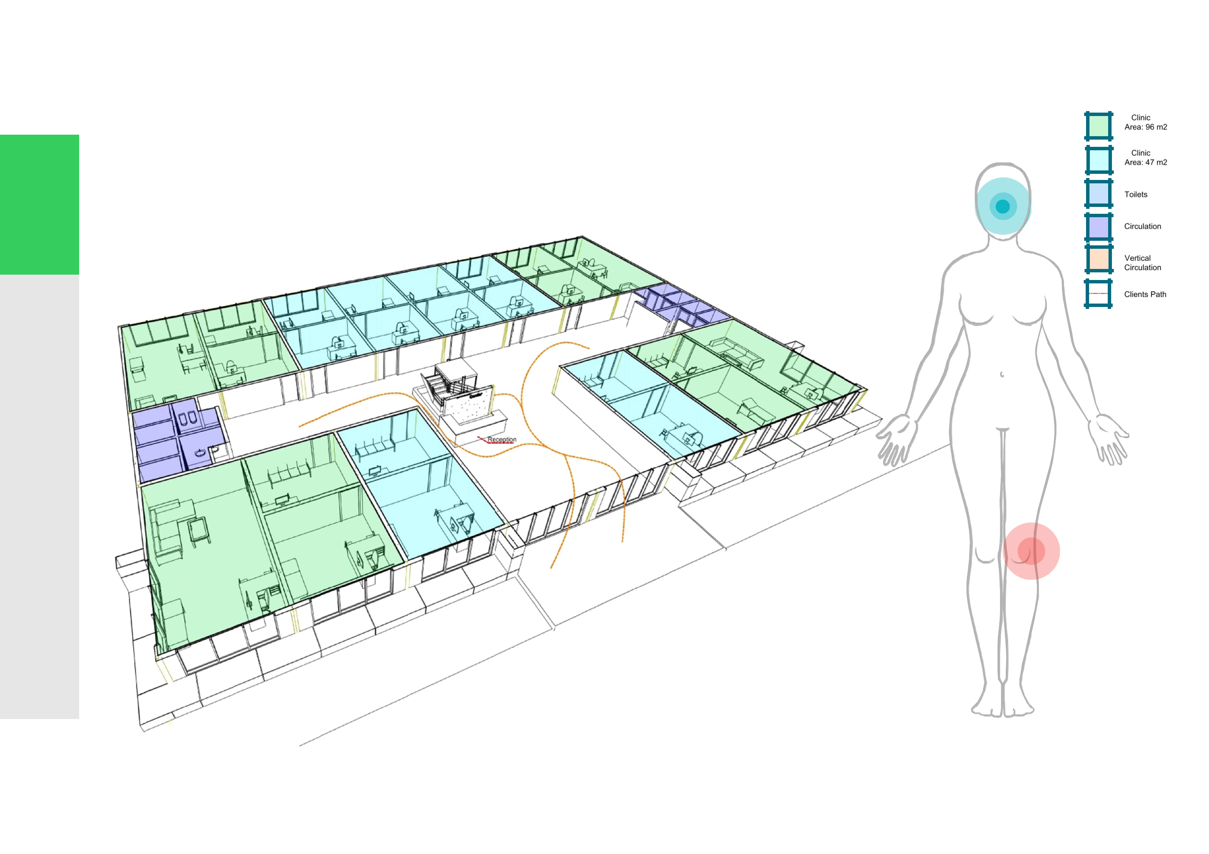

6 **Section**

Section Box



First Floor Layout & Section Box

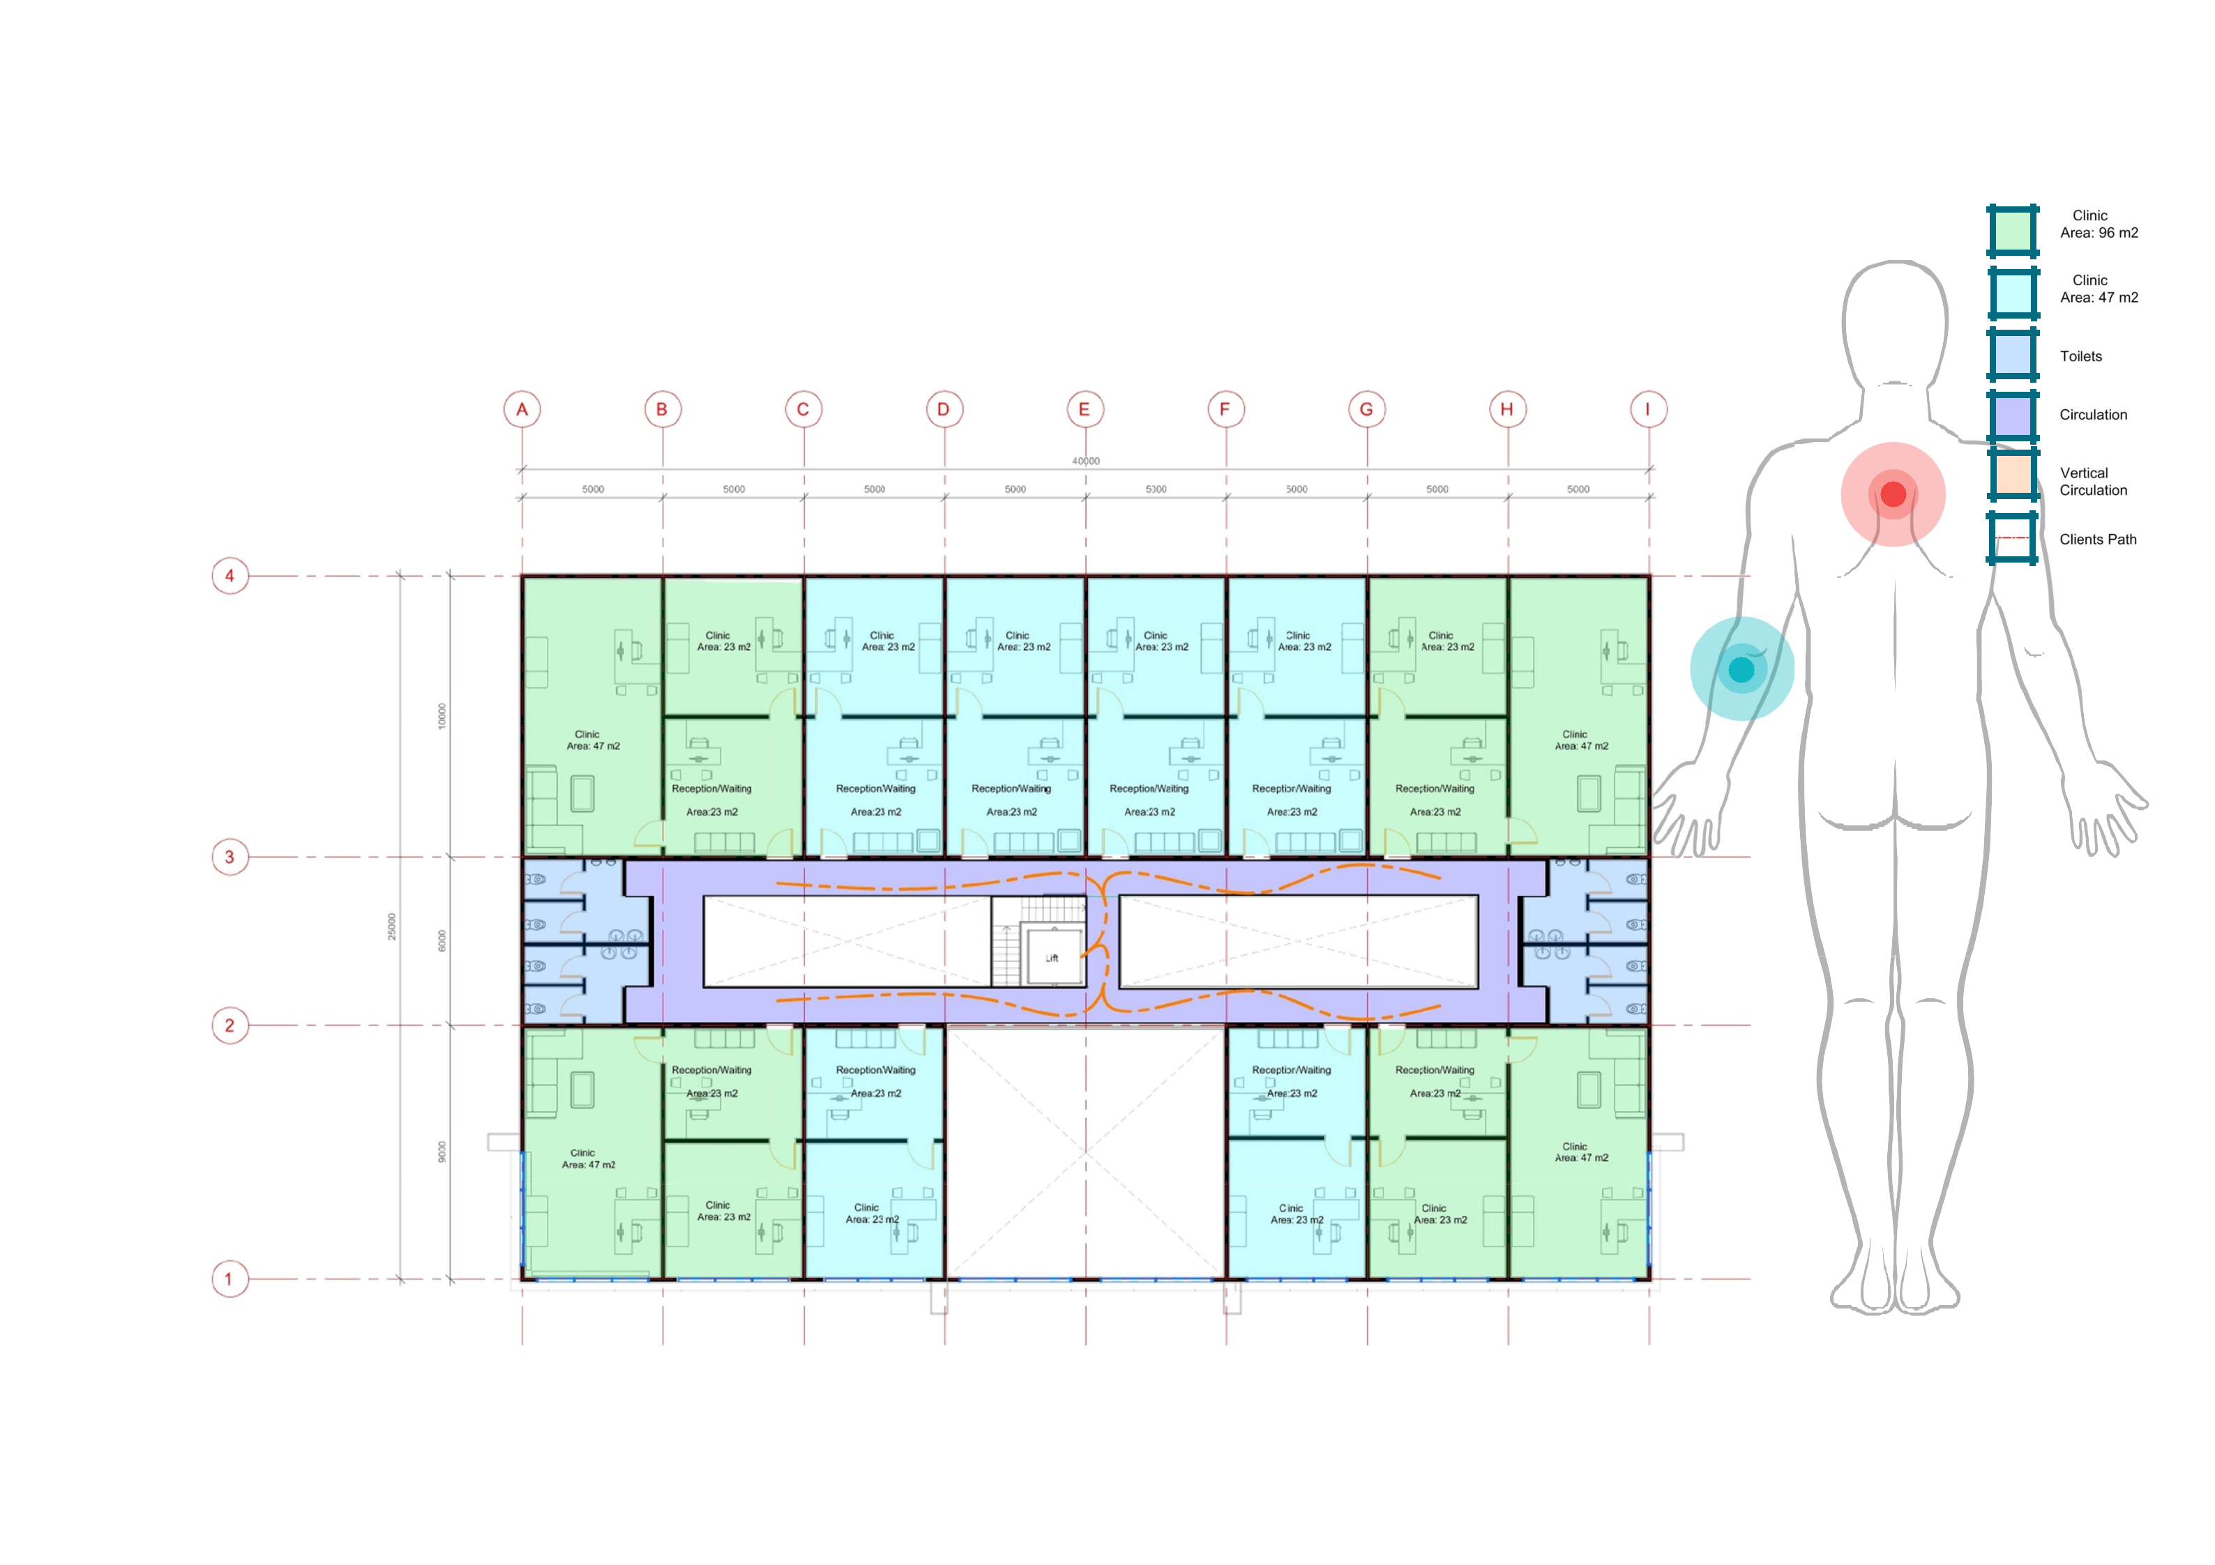

8 **Layout**

Layout

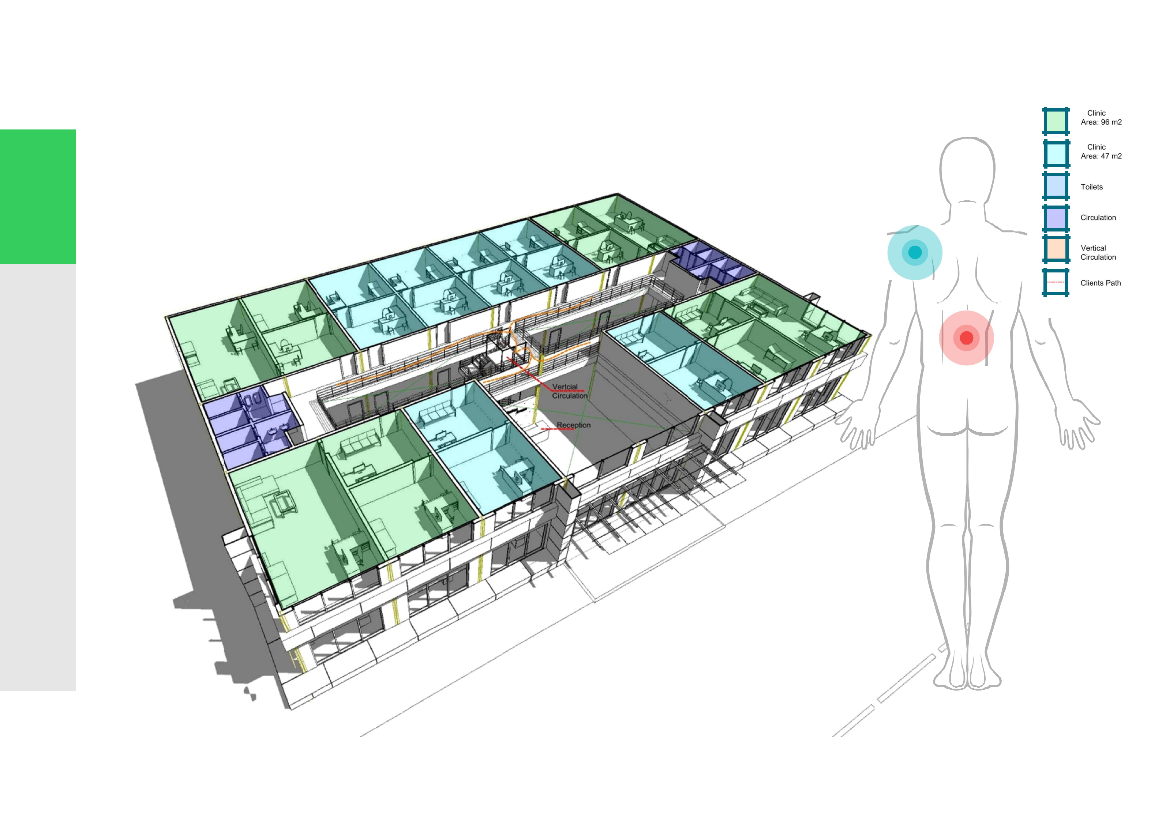

Section**Section**Box **Box**